# Py01 – Alien

## Introduction

This game is a classic Space Invaders-style game where you shoot aliens who try to drop bombs on you.

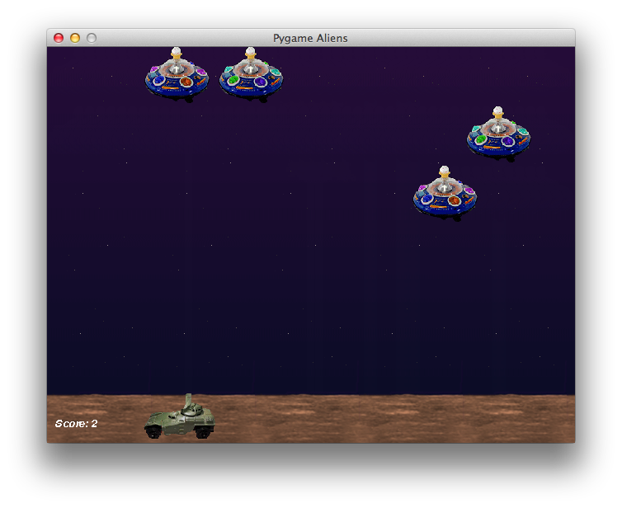

## Step 1: Play the game and take some notes

Play the game a couple of times. To do this, choose Run – Run from the menus at the top of the PyCharm window.

What kinds of objects can you see? Make a list of all the different objects you see in the game:

_______________________

_______________________

_______________________

_______________________

_______________________

_______________________

For some of these kinds of objects, there might be several on the screen at once. For others, there’s always exactly one. Put a star next to the objects where there might be several of them.

## Step 2: Find the different classes of object in the code

Look through the code for lines which follow this pattern:

class ***something*(**pygame.sprite.Sprite)

Where “something” is, err, something that isn’t just ‘something’.

Each of those matches one of the objects you already wrote down. Write down the exact name of the class, given in the code, next to the list you already made.

Did you miss any in your list?

## Step 3: Which images are used by each type of sprite?

You can see the different image files in the “data” directory. Which kinds of sprite use each file?

|  |  |
| --- | --- |
| alien1.gif |  |
| alien2.gif |  |
| alien3.gif |  |
| background.gif |  |
| bomb.gif |  |
| explosion1.gif |  |
| player1.gif |  |
| shot.gif |  |

Are any of the images not used by a sprite? How are they used?

## Step 4: Make the aliens move more slowly

I can’t score above 11. The aliens are too good.

1. Make the aliens go a bit slower.

## Step 5: Make the explosions last twice as long

1. Make the explosions appear on the screen for twice as much time.

## Step 6: Change the colour of the ‘Score’ text to blue

1. Make the colour of the score blue instead of white.
2. Make the font size a bit bigger.
3. Stop it from being italic (*slanty text like this*).
4. Make it bold instead.

## Step 7: Make the game full-screen

1. Work out how to make it full-screen. You may need the hints below:

Hint 1: the code starting with:

def main

is the first bit of the program, kind of like the “When green flag clicked” bit in Scratch. The first thing it does is to set up sound and an area of the screen (a “window”) to show the game in. So look there…

Hint 2: code starting with

#

means it is just a “comment” – that means, it’s for human beings (you!) to read, not for the computer.

Hint 3: sometimes such comments contain bits of code you could use instead…

To be continued…